Business CareWare


CABS AutoEmail Email Setup SQL Database Mail
How To Document

Document Changes

Date | Version | Change Description | Changed By
05/10/2016 | 1.0 | Original Version | TT

Table of Contents
1 Introduction 3
2 Setup SQL Database Mail 3

Introduction

This document provides a description of how to setup SQL Database Mail for use with CABS AutoEMail. CABS AutoEMail uses the profile name in the email template configuration (setting EmailProfile). SQL Database Mail is the mechanism used by CABS to transmit emails.

Setup SQL Database Mail

Based on setting up a new Profile on a SQL Server 2008 Installation
- In SQL Server Management Studio, expand the Management folder, right-click on Database Mail and select “Configure Database Mail”.
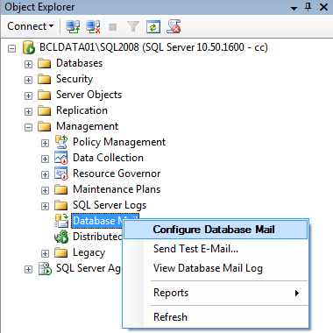
Figure 1 - Configure Database Mail

- Select the “Set up Database Mail by performing the following tasks:” option and click Next.
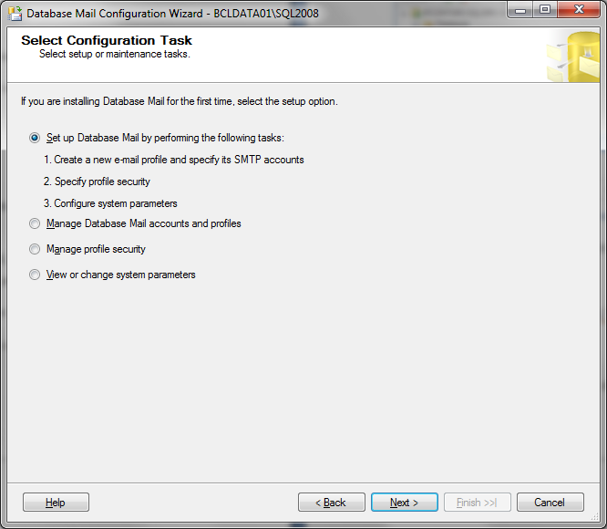
Figure 2 - Setup Database Mail
- Enter a Profile Name and Description and click Add to create a new account.
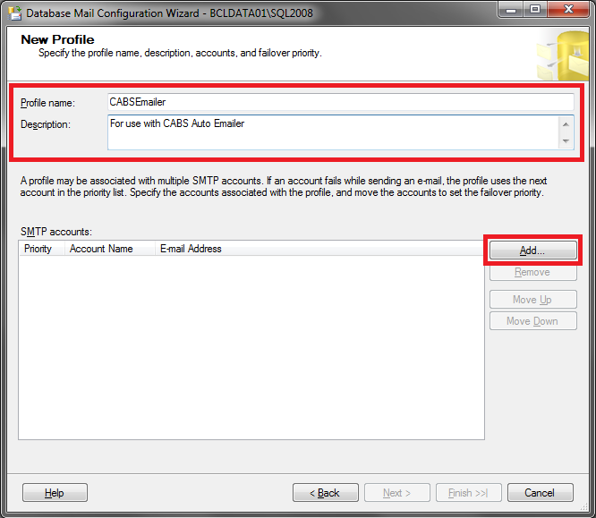
Figure 3 - Create Profile
- Click New Account
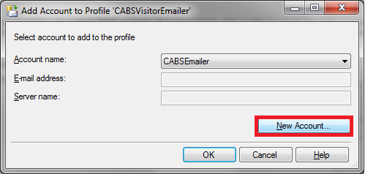
Figure 4 - Create New Account

- Complete the required details for your SMTP Server for use with the Profile and click OK.
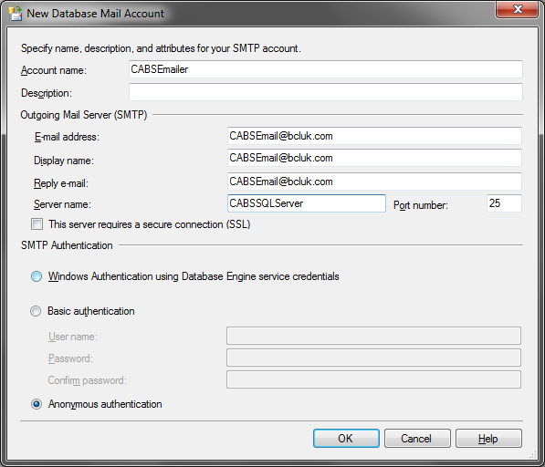
Figure 5 - Add SMTP Details
- Click the “OK” button.

